**SSRP project templates**

**Title:** Estimating effects of droughts on food security in Kenya

**Theme:** Statistical and econometric analysis of impacts of droughts on food security in Kenya with the aim to improve existing early warning famine systems.

**SDG’s:** 2. Zero hunger, 3. Good wealth and wellbeing, 1. No poverty

**PI and Co PI details:**

Pedram Rowhani (Global Studies, Geography), Martin Todd (Global Studies, Geography), Annemie Maertens (Economics, BMEc), Dominic Kniveton (Global Studies, Geography)

**Project team**: Besides the PI and CoPI: National Drought Monitoring Agency (NDMA) in Kenya, Monika Novackova

**Where are you working:** Kenya

**Project summary in 140 characters:** Estimating of impacts of droughts on food security in Kenya using statistical and econometric models

**Overview of project:** The project is focused on analysis of mechanisms of effects of high impact drought events on food security in Kenya. The outputs will improve the existing early warning system, which will contribute to timely identification of the most vulnerable areas and communities. This will lead to improvement of distribution of humanitarian aid which is necessary for preventing or alleviating catastrophic consequences of extreme weather events on peoples’ life, health and well-being.

**Project description:**

We will identify which particular weather events lead to most harmful consequences on food security. We will also explore the underlying mechanisms of effects of droughts on food security by means of statistical analysis and econometric models. In particular, we will focus on estimating of effects of precipitation and various droughts indicators on food production, food prices and other aspects of human wellbeing applying panel regression models.

As the government of Kenya is relatively decentralised, many important decisions including those about public finances are made at county level. Therefore, our analysis will be conducted at county level. There are 47 counties in Kenya including 23 lying in arid and semi-arid areas, which are especially prone to droughts. The time focus of our analysis is from 1970 until present.

The source of our weather data is the Climate Research Unit (CRU). The yearly food production data and monthly food price data come from the Famine Early Warning Systems Network (FEWSN). For the main analysis, we will use yearly average of food prices as the yearly frequency is conformable with the yearly frequency of the production data. We will apply various methods of panel data analysis, including fixed effects and random effects controlling for potentially confounding variables. The different specifications and their varieties will be assessed and compared and we will use the preferred specification to infer conclusions.

**Timeline and funding:** April 2017-September 2018

**Photos:**

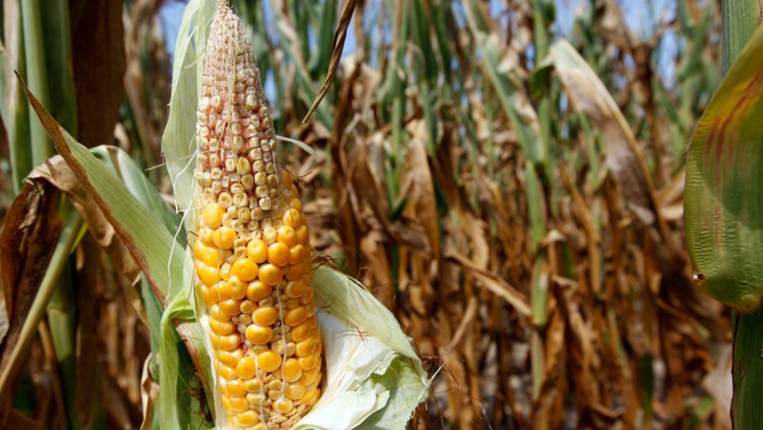

**source** [**https://gdb.voanews.com/4CC0E226-76DA-4C35-9AA1-E795BFC98663_cx0_cy5_cw0_w1080_h608.jpg**](https://gdb.voanews.com/4CC0E226-76DA-4C35-9AA1-E795BFC98663_cx0_cy5_cw0_w1080_h608.jpg)

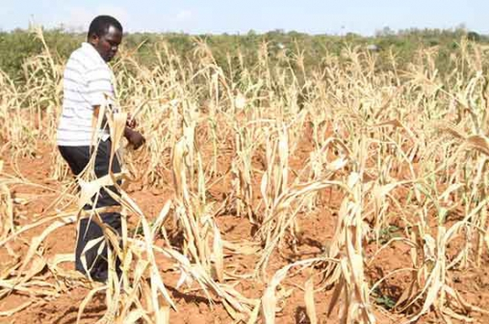

**Source:** [**https://www.standardmedia.co.ke/article/2000224071/new-strategy-on-soil-mapping-to-help-curb-food-insecurity-in-kenya**](https://www.standardmedia.co.ke/article/2000224071/new-strategy-on-soil-mapping-to-help-curb-food-insecurity-in-kenya)

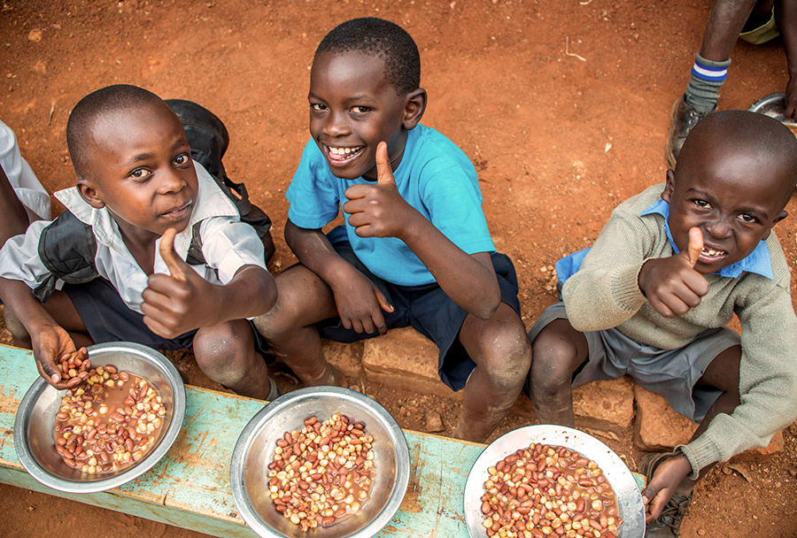

**Source: https://www.compassion.com.au/blog/understanding-the-east-africa-drought**

**Any useful websites or links:**

NDMA:

<http://www.ndma.go.ke/index.php>

Forpac:

<https://www.forpac.org/>

IPC:

http://www.ipcinfo.org/ipcinfo-countries/ipcinfo-eastern-middle-africa/Kenya